| **SOLVING SIMPLE PROBLEMS IN C**  **LAB 2**  **SECTION 5**  **SUBMITTED BY:**  **JACKSON COLLALTI**  **SUBMISSION DATE:**  **09-12-2022** |
| --- |

**Lab Problem**

The purpose of this lab is to create five simple programs which help build a foundation for creating future programs. Problem 1, create a program that prints information. Problem 2, modify a program that calculates the area of a rectangle and change it to calculate the volume of a rectangular prism. Problem 3, uses a given program to identify common errors in the code and fixes the issues. Problem 4, create a program that prints the result of different calculations. Problem 4, part 2, creates and runs a program that can be used for conversions. Problem 5, create a program that uses the Pythagorean theorem to find the hypotenuse after putting inputs in for the legs.

**Analysis**

Problem 1, no inputs are needed to solve the problem. Criteria is for the program to show my full name, class title, and the date, each of which needs to be on a new line. In my case the output should be

Jackson Collalti

CPRE185

09/06/2022

Problem 2, initially, the program has two inputs (width, height) and one output (area). To change the program to calculate the volume of a rectangular prism I need to add an input (depth). To get the output to be the volume I need to add the new variable (depth) to the area equation.

Problem 3, Given code that doesn’t run calculations as intended. I’m tasked with finding and fixing equations and statements causing the issues.

Problem 4, Given equations for variables I need to print the output to match the type of variable assigned. This means I need to identify whether to use %lf or %d in the print statement. Part 2, Calculate and output the area of a circle when the input is the circumference, convert feet into meters (1 ft = .3048 m), and Convert Fahrenheit to Centigrade (Tc=(Tf - 32) / 1.8).

Problem 5, made a program that uses Pythagorean Theorem (a^2 + b^2 = c^2) to use two inputs (a and b) to find the hypothenuse (output).

**Design**

Problem 1, since I don’t need inputs to run the function I can use just a single print statement. In the print statement, I’ll need to use \n ’s in order to create the new lines.

Problem 2, After running the given code make sure it runs properly. I need to add another variable “z” to represent the depth of the prism. This means I’ll need to add another set printf and scanf. Then I have to add my new variable, z, to the original area equation giving me the volume equation.

Problem 3, looking at the code for the first equation I’ll need to change the %lf to %d in the print statement since the output is meant to be an integer and %d is what’s used for integers. In the second equation, the %d has no variable assigned to it, so I need to add integerResult to the end of the print statement. The third equation is similar to the first equation just reversed, the desired output is a decimal form so %lf is used, not %d.

Problem 4, The basic format I’m going to follow is declaring a variable, an equation for the variable, and printing the result of the equation using the variable. I’ll need to use %lf for doubles and %d for ints. Problem 4 part 2, for circumference to the area I will need to get the input for circumference using print and scan statements and use that input to get the radius. Then once I get the radius, I square it and multiply by pi then print the output. To convert ft to meters using 1 ft = 0.3048 I need to create an input for feet and display the output of the conversion in meters. For Fahrenheit, to Centigrade I need to use the input Fahrenheit and convert that to Centigrade using Tc = (Tf - 32) / 1.8 and display the output. In all of part two, the inputs and outputs are measurements so doubles will be the variables used.

Problem 5, I plan on creating an input variable a and b then an output variable c. Since the given source code provides the square root I need the set up the equation c = a^2 + b^2.

**Testing**

For testing all cases I would run the code to make sure no error came up in compiling and running. Using the inputs given in the instructions and would test to see if the outputs matched what I was expecting. For the problems that didn’t have inputs, I would run the code and evaluate the results.

**Comments**

This lab introduced me to writing code and running it. This was the first time I used NotePad++ to write, and my first time using CygwinTerminal. The code I wrote was simple and related to what we learned in class and through homework. I learned how to run a program by using gcc … -o … and ./. The instructions were pretty straight forward the only problems that occurred were I initially did meters to ft instead of feet to meters in problem 4. Originally finding out how to run the program was a challenge but after the TA showed us it was easy. A problem that I ran into and couldn’t figure out was I couldn’t save a txt file of my problem 4. I plan on asking a TA how to do that before Lab 3. Another issue that was more significant was that when reopening files such as accessing my 2_4 code it looked like the image below

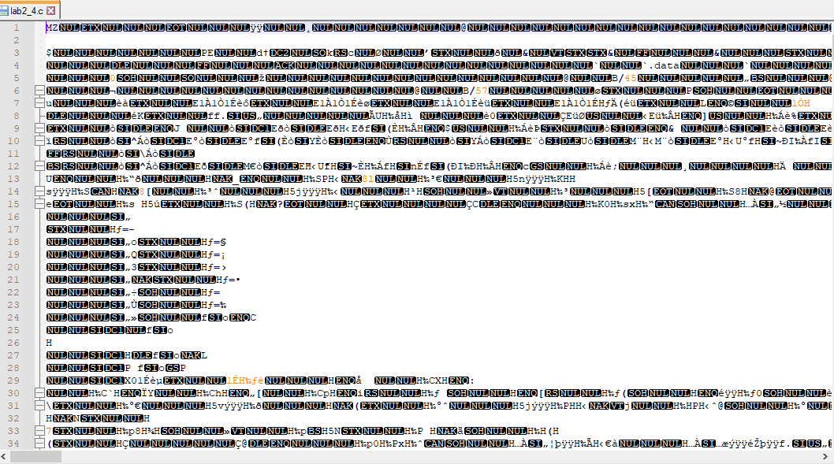

When I ran into this issue I didn’t know how to resolve it. I couldn’t get the code back, so I had to rewrite it.

**Implementation**

Source Codes Given by Instructor

1)Format for how to code

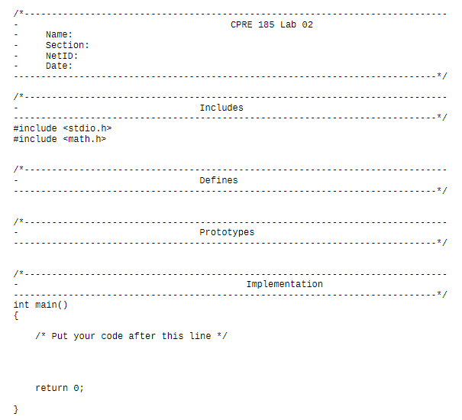

2)Start of 2_3

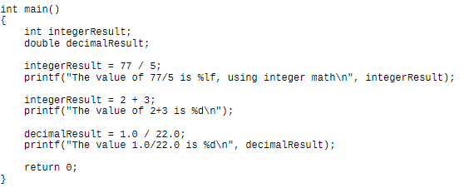

3)Start of 2_5

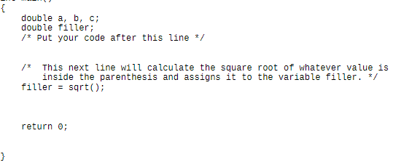

**Problem 1**

Code

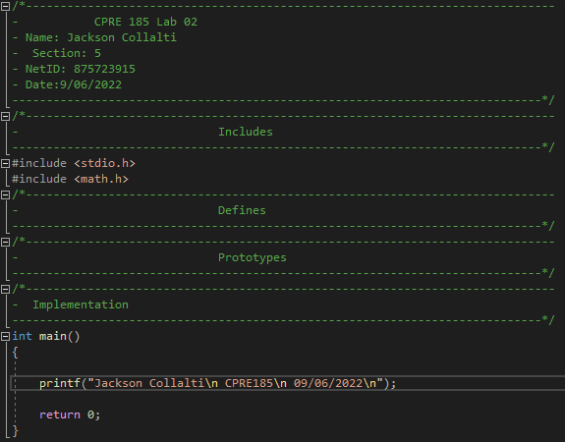

Output

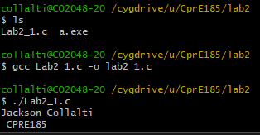

**Problem 2**

Code

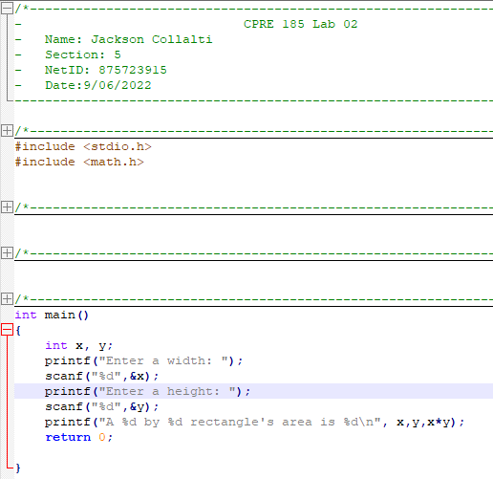

Output

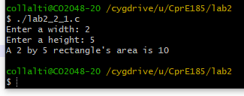

Problem 2, Part 2 Code

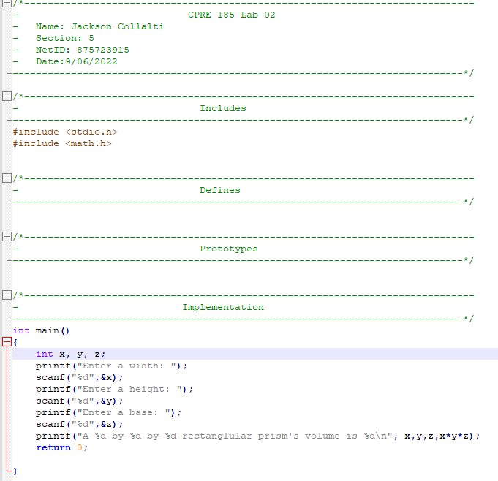

Problem 2, Part 2 Output

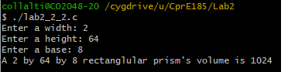

**Problem 3**

Original

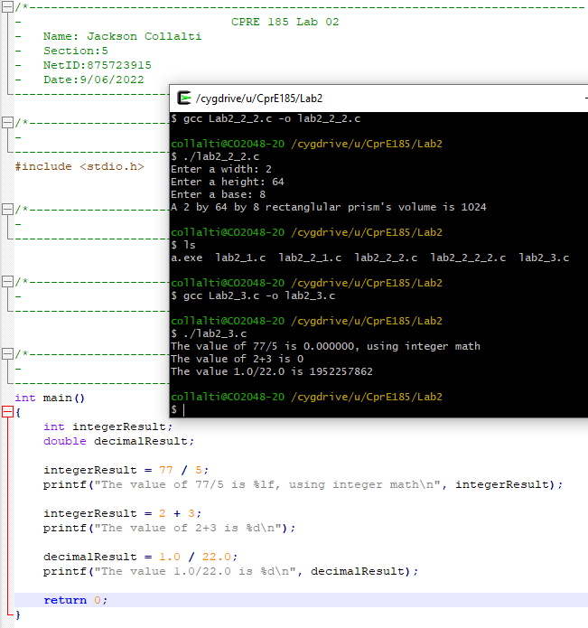

Problem 3 Corrected

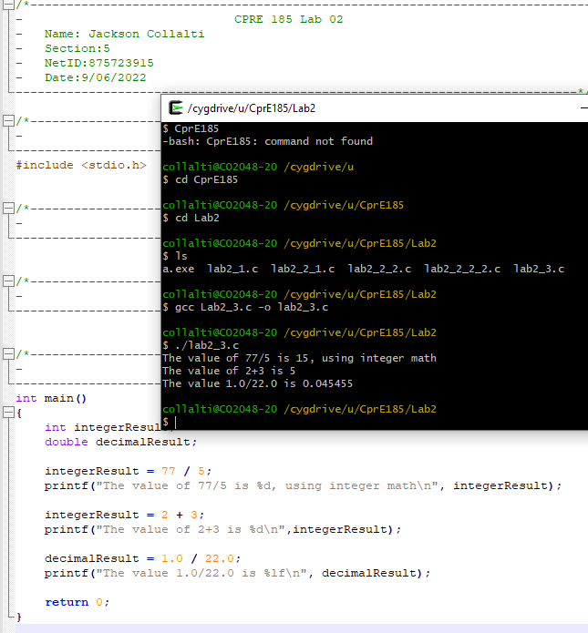

**Problem 4**

Code

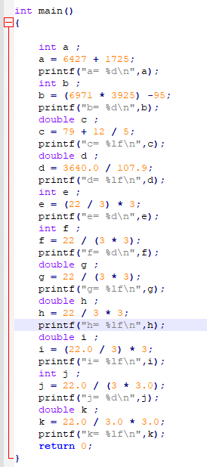

Output

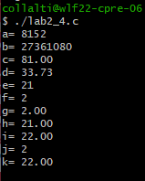

Circumference to Area Code

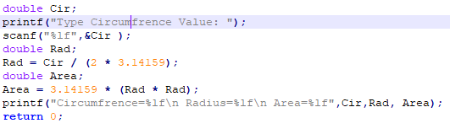

Circumference to Area Output

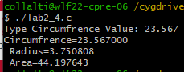

Feet to Meters Code

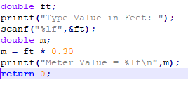

Feet to Meters Output

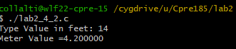

Fahrenheit to Centigrade Code

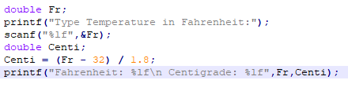

Fahrenheit to Centigrade Output

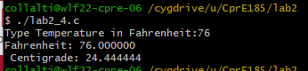

**Problem 5**

Code

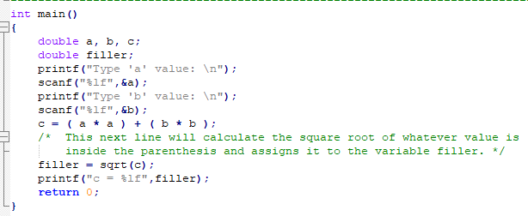

Output

